horizontal line

**EE208:CONTROL ENGINEERING LAB 10**

**Dynamic studies of a nonlinear mechanical system on Simulink.**

**Course Instructor : Dr. Sanjay Roy**

**Date : 2nd April 2022**



**Group Number - 14**

**Raj Kumar Deb 2020eeb1025**

**Tushar Sharma 2020eeb1325**

**Tiya Jain 2020eeb1213**

# 

# TABLE OF CONTENTS

**1. OBJECTIVE** **3**

**2. GIVEN INFORMATION** **3**

**3. REFERENCES FROM LAB 08** **4**

**4. SIMULINK SIMULATION** **5**

**5. DYNAMICS OF THE CRANE FROM ONE STEADY-STATE TO ANOTHER** **7**

5.1 Step Input 7

5.2 Impulse Input (for 1 second) 8

5.3 Ramp input 9

**6. ANALYSIS OF THE BEST INPUT FOR THE NONLINEAR SYSTEM** **11**

**7. DISCUSSIONS ON VARYING THE LOAD MASS** **12**

7.1 Step Input 12

7.2 Impulse Input 13

7.3 Ramp Input 13

7.4 Bang-Bang Input (Most preferable case) 14

**8. DISCUSSIONS ON VARYING THE MAGNITUDE OF INPUT FORCE** **15**

8.1 Step Input 15

8.2 Impulse Input 16

8.3 Ramp Input 17

8.4 Bang Bang Input 18

**9. DISCUSSIONS ON VARYING INITIAL POINTS** **19**

9.1 At odd π 20

9.2 At even π 20

9.3 At non-integral π 20

**10. CONCLUSION** **21**

**11. MATLAB SCRIPT** **22**

# 

# 1. OBJECTIVE

Dynamic studies of the given crane trolley system on Simulink, using a detailed nonlinear state space system simulation in four state variables.

# 2. GIVEN INFORMATION

* Differential equation of a simplified model of an overhead crane:
$[m_{L} +m_{C} ] . x_{1}"(t) + m_{L}l. [x_{3}" (t) .cos x_{3}(t) −{x_{3}'}^{2}(t) . sinx_{3}(t) ]= u(t)$

$m_{L} . [ x_{1}"(t) . cos x_{3}(t) + l .x_{3}" (t)] = − m_{L}g. sinx_{3}(t)$

* Parameters :
  + Arbitrary : $m_{l} (Mass of hook and load) and l (Rope length)$
  + Constant: $m_{C} (Mass of trolley; 10 kg) and g (Acceleration due to gravity, 9.8 ms^{-2})$
* Variables :
  + Input:
    - u: Force in Newtons, applied to the trolley.
  + Output:
    - y: Position of load in metres, . y(t) = x1(t) + l . sin x3(t)
  + States:
    - x1: Position of trolley in metres.
    - x2: Speed of trolley in m/s.
    - x3: Rope angle in rad/s.
    - x4: Angular speed of rope in rad/s

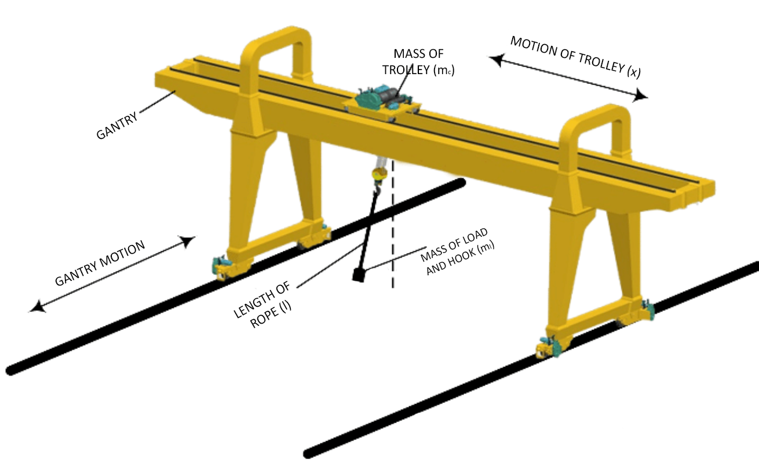

Figure 3.1 Overhead Crane

# 3. REFERENCES FROM LAB 08

* At any point of time, the system is completely described by the given four states $x={[x_{1} x_{2} x_{3} x_{4}]}^{T}$.
* From given definitions of x1 and x2, we can infer that $x1’ = x2 \& x3’ = x4$.
* The only input ‘u’ is the force applied to the trolley(in horizontal direction and hence affects the rate of change of speed i.e. x2’).

And the output position is given by y(t) = x1(t) + l.sin(x3(t))

* From the observations of experiment #8, we concluded that the state variables at equilibrium points were of the form [x1 0 n*𝝅 0]T and further analysis at these points revealed that the system is highly unstable at points of the form [x1 0 𝝅 0]T which is identical to all values of x3 as odd multiples of 𝝅, and remains marginally stable (only for the ideal case neglecting any friction) for points of the form which is identical to all values with even multiples of 𝝅 and with the input force as ‘0’.
* The input value of force as zero here is understandable as with non zero value of force, the trolley will keep on accelerating and hence x2’ and x1’(i.e. x2) cannot be ‘0’, which is a requisite for linearisation (derivatives of state variables). Similar is the case here with nonlinear systems : When we apply a non zero force (step and ramp), then the value of speed changes and hence distance keeps on increasing, so we need to apply brakes (in other words, a force of same magnitude and opposite direction to reduce the speed to 0 again and hence restrict further movement of the trolley once positioned in its desired location.

# 

# 

# 

# 

# 

# 4. SIMULINK SIMULATION

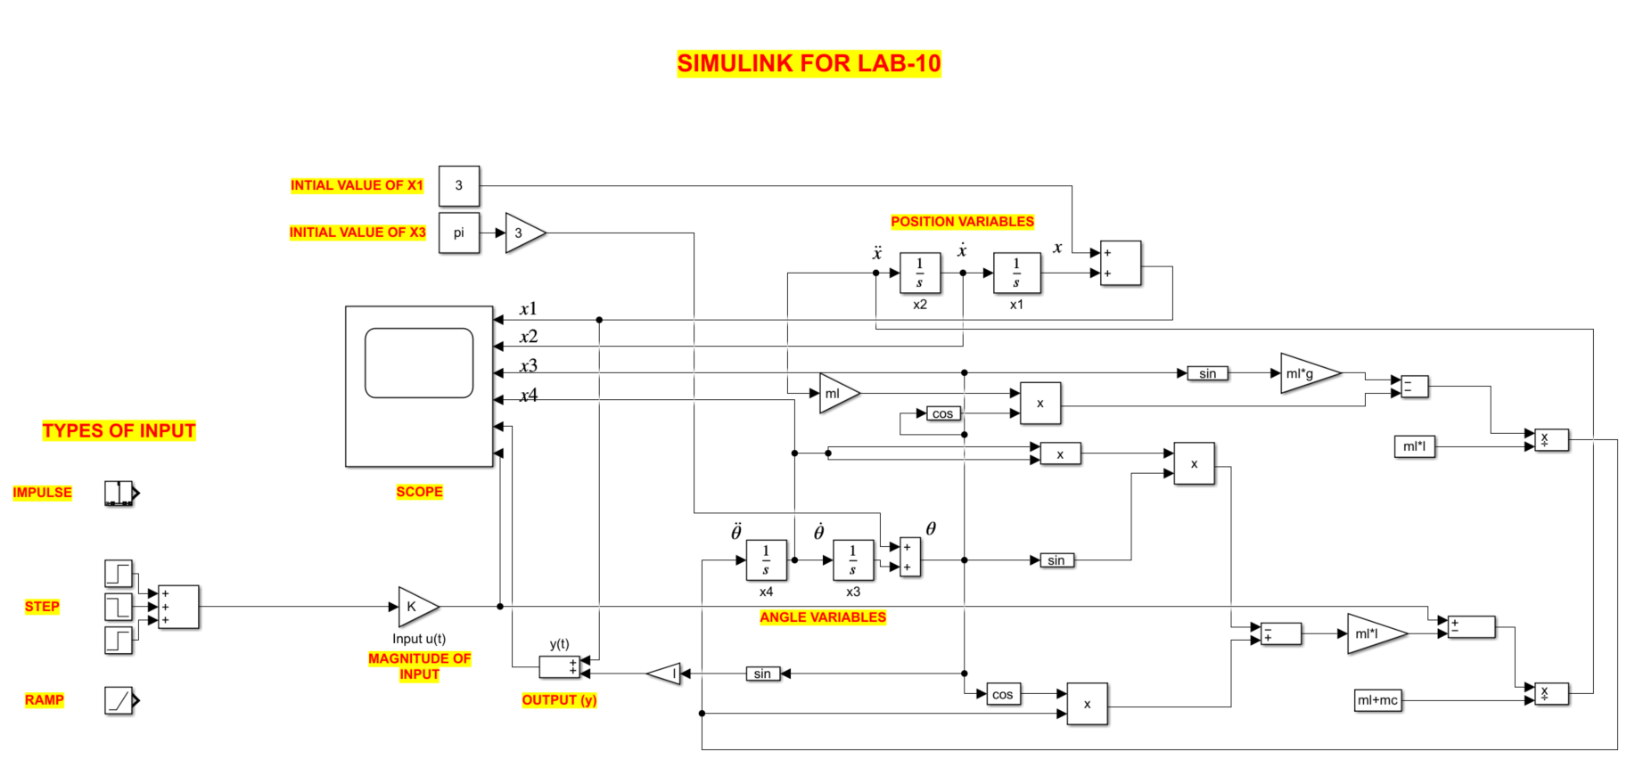

## 4.1 A brief description :

From the equations given to us :

$[m_{L} +m_{C} ] . x_{1}"(t) + m_{L}l. [x_{3}" (t) .cos x_{3}(t) −{x_{3}'}^{2}(t) . sinx_{3}(t) ]= u(t)$

$m_{L} . [ x_{1}"(t) . cos x_{3}(t) + l .x_{3}" (t)] = − m_{L}g. sinx_{3}(t)$

We began with the blocks for double derivative terms (x1” i.e. x2’ and x3” i.e. x4’) in our simulink model and then derived the terms with single derivative (x1’ i.e. x2 and x3’ i.e. x4) using an integrator block (for each) and further obtained the states x1 and x3 by cascading integrator blocks again. Further by using suitable blocks (gain block, constant block, product block, divide block, subtract block, sine block and cosine block) we connected the circuit in our Simulink model accordingly such that it behaves analogously to the set of the above given equations.

###### **Comments : We were precautious while picking up input values as we change parameters like step time, final time and initial time according to our needs.

###### We also worked with different magnitudes of particular kind of input forces (step, impulse and ramp) with the help of additional gain block K in our Simulink model

###### **Notes :

###### We used the integrator blocks instead of the derivative block since we generally avoid using derivative blocks as they consume more power compared to integrators.

# 

# 5. DYNAMICS OF THE CRANE

We took the initial states for the study as x = [0 0 0 0]. This also refers to the fact that our system is in marginally stable equilibrium (*x3 is an even multiple of π*).

## 5.1 Step Input

The graphs below are plotted when the mass of the load and the hook is equal to 10kg.

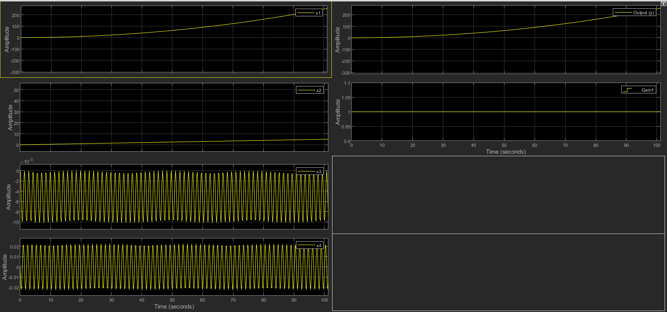

### 5.1.1 Trace of x1 Position of trolley in metres.

* We observe that the x1 state starts to increase rapidly with time with increasing slope.
* This is expected as the input is a constant force of unit magnitude (step input) starting from time t = 0, the acceleration is constant and hence the velocity increases linearly following which the value of x1 increases rapidly and gives us an ever increasing plot.

### 5.1.2 Trace of x2 Speed of trolley in m/s.

* The plot of x2 (speed) w.r.t. time obtained is linear in this case (since force is constant here and hence is the acceleration).
* $x1’ = x2$ is the relation here, hence as x2 is linear with positive slope, we observe rise in x1 w.r.t. time with an increasing slope (magnitude given by x2 at that time which keeps increasing).

### 5.1.3 Trace of x3 Rope angle in rad/s.

* The observation in the variation of this state is that it is oscillatory in nature

### 5.1.4 Trace of x4 Angular speed of rope in rad/s

* We observe a similar oscillating pattern in the x4 state as we observed in the x3 parameter.
* We note that due to the relation between x3 and x4 as $x3’ = x4$ and hence we get a phase difference of $π/2$ in the graphs of x3 & x4.

## 5.2 Impulse Input

The graphs below are plotted when the mass of the load and the hook is equal to 10kg.

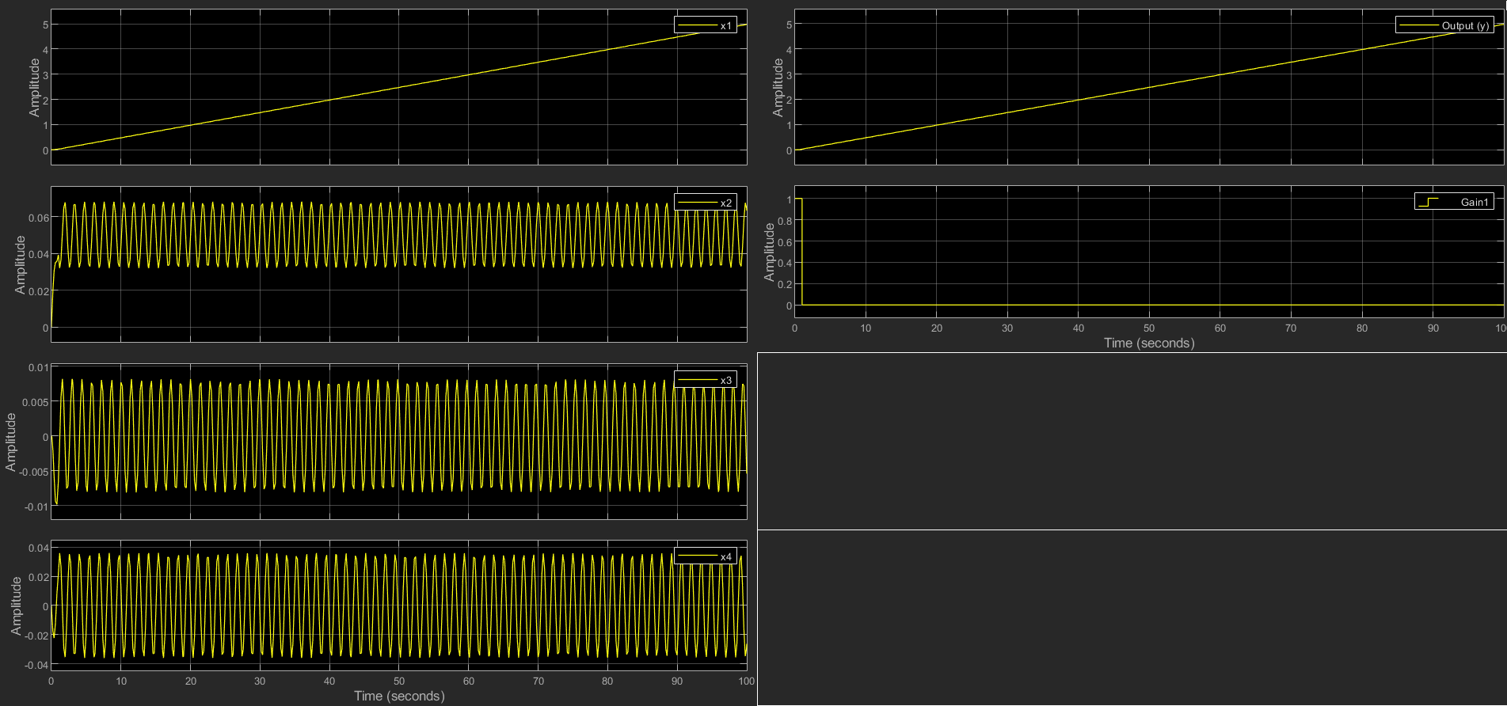

### 5.2.1 Trace of x1 Position of trolley in metres.

* We observe an almost linear relationship between the amplitude of x1 v/s time plot. It is approximately linear as the speed x2 keeps oscillating about a value of 0.05m/s; had it been a constant value, the graph would have been exactly a straight curve. It looks almost straight unless zoomed in to notice the minute deviations from the straight line behaviour.

### 

### 5.2.2 Trace of x2 Speed of trolley in m/s.

* Starting from the origin we observe the value of x2 state rises for a small interval of time since the force remains applied for a time period of 1 second (impulse), after which we observe oscillatory behaviour of speed of the trolley about an amplitude of (0.05 m/sec).
* This is because of the shear reason of inertia of the mass load the velocity of the trolley also experiences an oscillatory nature.

### 5.2.3 Trace of x3 Rope angle in rads.

* The angle of the rope also starts to oscillate with a specific amplitude (<0.01) after the impulse force is taken off. Before that we observed a fall in angles of the rope and therefore negative angle (up to -0.01).
* The sudden change in angle must have occurred due to the impulse force which led to a jerk and hence the angle changed on appliance of the impulse force at t=0. As soon as the force is removed (since it is an impulse), the mass would start oscillating about the equilibrium position (about x3 = 0)

**5.2.4 Trace of x4 Angular speed of rope in rad/s**

* This state starts to oscillate about 0 rad/sec and the amplitude for the same is around 0.035 rad/sec.

## 5.3 Ramp input

The graphs below are plotted when the mass of the load and the hook is equal to 10kg.

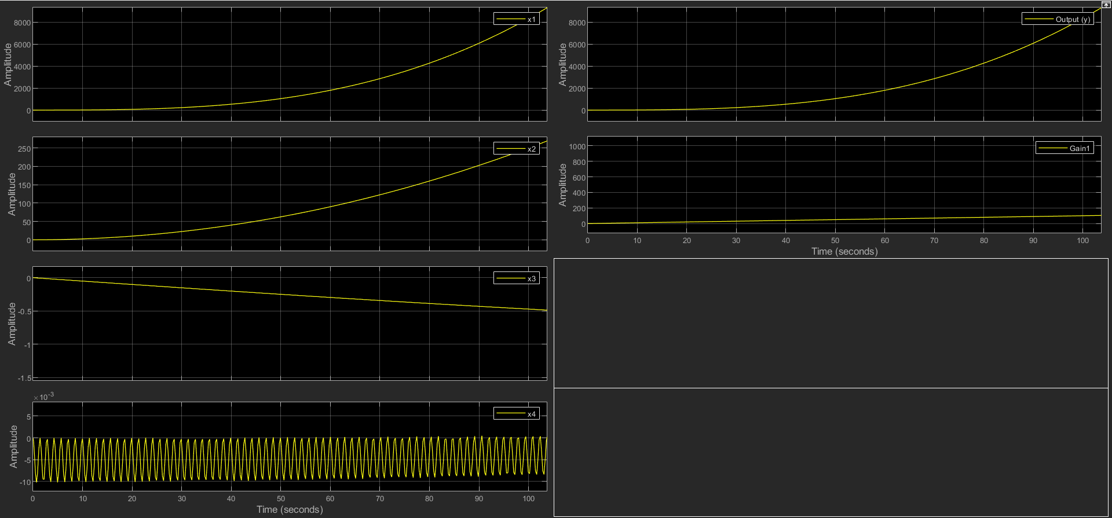

### 5.3.1 Trace of x1 Position of trolley in metres

* This state x1 gives a rapidly rising plot as time increases. The graph shows a trend similar to that of x1 ∝ t3. This relationship was expected for a ramp input (since a force and hence acceleration proportional to t would give a speed proportional to t2 and hence a distance proportional to t3).

### 5.3.2 Trace of x2 Speed of trolley in m/s.

* The plot of x2 v/s t shows a trend similar to that of x2 ∝ t2, which is expected as speed is proportional to square of time when force is directly proportional to time.

### 5.3.3 Trace of x3 Rope angle in rads.

* The plot showcases a negative slope starting from 0 and extends in the negative direction with increase in time. This is because of the form of the ramp input which is increasing in nature.
* The input force obtained due to the ramp response is only of a negative magnitude which results in the rope getting pushed in a single direction. Therefore, the angle between the rope and its initial position keeps on increasing and the rope never returns , or to frame it better never achieves the value 0 again.

### 5.3.4 Trace of x4 Angular speed of rope in rad/s

* The variation of the state x4 with respect to time is however obtained to be of oscillatory nature.

## 

# 6. ANALYSIS OF THE BEST INPUT FOR THE NONLINEAR SYSTEM

From our observations we already established that in order to stop our crane once started we need to apply a counter force in order to reduce the speed again to zero. So, we thought of an approach where we will be using some combinations of step inputs such that it functions for a period of time and then the crane stops moving when the net force equals zero after we reach a desired location.

So, we first tried with a combination of step inputs with positive and negative magnitude, such that there overall effect cancel each other

Hence we require an input force with first a positive magnitude and then a negative magnitude so that we are finally able to stop our crane after it starts moving and reaches its desired location.

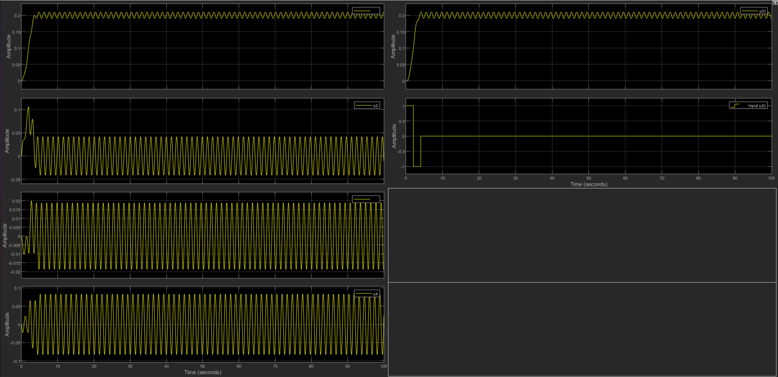

##### Figure 6.1 : The resulting graphs for an optimal solution approach

# 7. DISCUSSIONS ON VARYING THE LOAD MASS

Using the most preferable input we now start to vary the magnitude of the load mass of the crane $m_{l} (Mass of hook and load)$ which leads to very peculiar observations. We vary the total load from 10kg ( the case with only hook and no extra load ) to 1000kg with equal distribution of weight between any two consecutive cases.

## 

## 7.1 Step Input

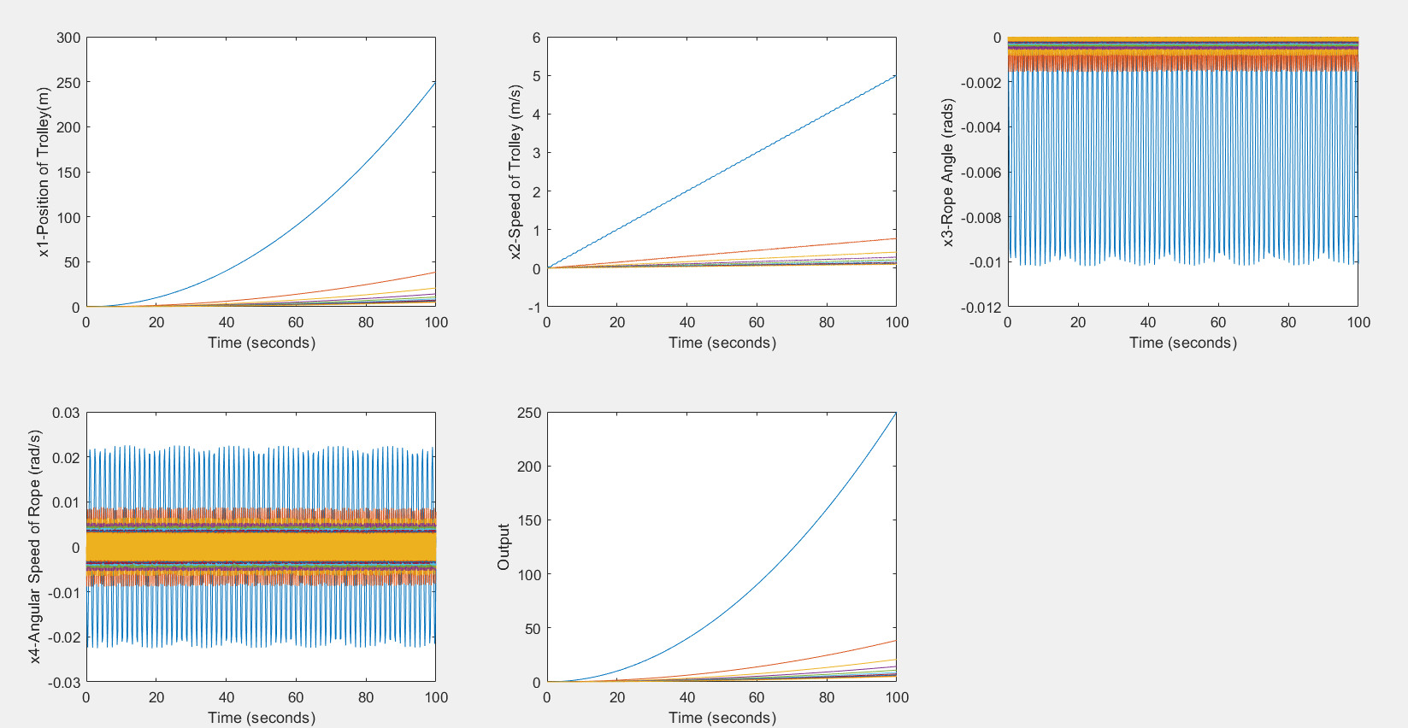

Trends : For a given value of step input, the value of **x1, x2 and output Y** corresponding to it *sharply reduces* as we increase the load mass. Further, the **frequency & amplitude** of oscillations of the load mass (x3) and also its angular speed (x4) *reduces gradually* as we increase the total mass of load and hook

## 7.2 Impulse Input

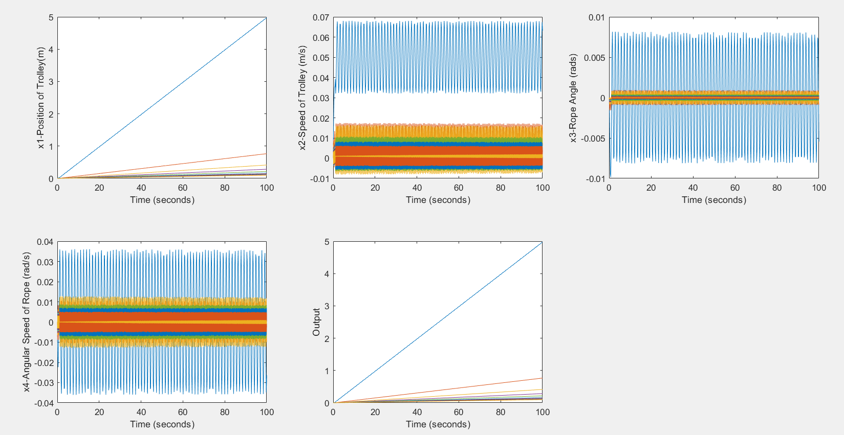

Trends: For a given value of impulse input, the value of **x1 and output Y** corresponding to it *sharply reduces* as we increase the load mass. Further, the **frequency & amplitude** of oscillations of the load mass x3, its angular speed x4, along with the trolley’s speed x2 *reduces gradually* as we increase the total load mass.

## 7.3 Ramp Input

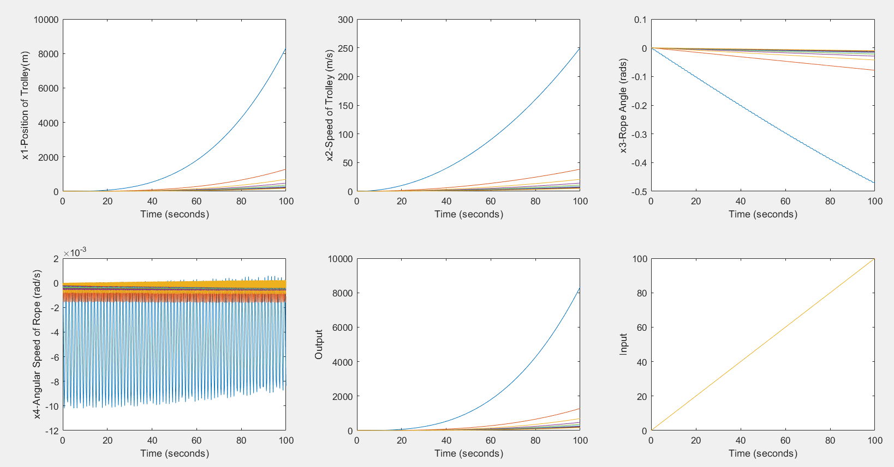

Trends: For a given value of input ramp force, the value of **x1, x2 and output Y** corresponding to it *reduces* as we increase the load mass. The modulus of the slope of x3 decreases as we increase the mass load. The amplitude of oscillation of x4 is highly affected by the mass load variation as we observe huge decreases in amplitudes even if we increase the mass load in a small measure.

## 7.4 Bang-Bang Input (Most preferable case)

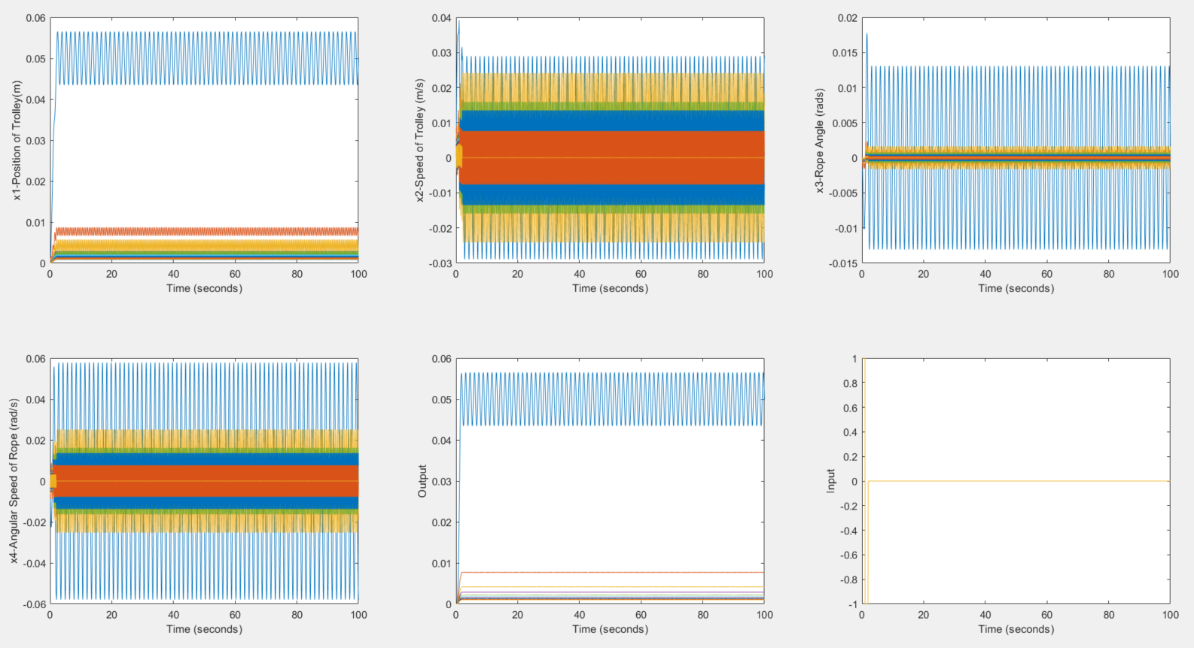

Trends: For a given value of bang bang input, the value of **x1 and output Y** corresponding to it sharply reduces and starts oscillating about that reduced point as we increase the load mass . Further, the frequency of oscillations of the load mass x3 and also its angular speed x4, along with the trolley’s speed x2 reduces gradually as we increase the total load mass.

# 8. DISCUSSIONS ON VARYING THE MAGNITUDE OF INPUT FORCE

Using the most preferable input we now start to vary the magnitude of the load mass of the crane $m_{L} (Mass of hook and load)$ which leads to very peculiar observations. The interval of magnitude taken into consideration is : 10 values of force from 1N to 100N with an equal distribution.

## 

## 8.1 Step Input

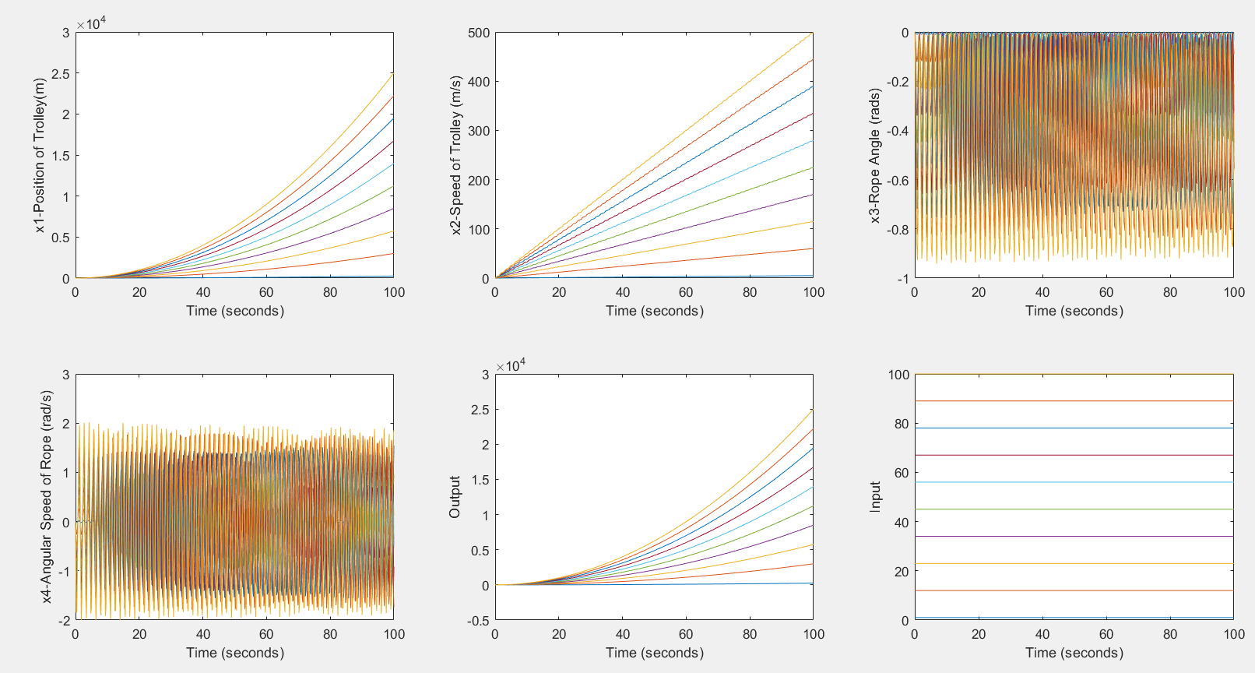

Trends: For a given value of step input, the value of x1, x2 and output Y corresponding to it increases as we increase the magnitude of input step force. Further, the amplitude of oscillations of the load mass (x3) and also its angular speed (x4) increases gradually as we increase the input force on the system.

## 

## 

## 8.2 Impulse Input

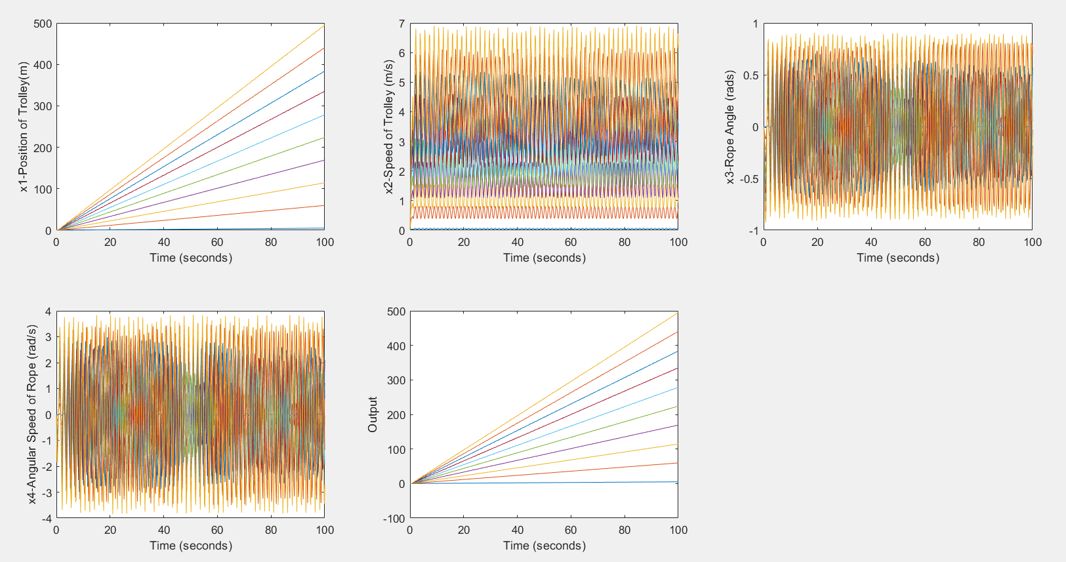

Trends: For a given value of impulse input, the value of x1, x2 and output Y corresponding to it increases as we increase the magnitude of input step force. Further, the amplitude of oscillations of the load mass (x3) and also its angular speed (x4) increases gradually as we increase the input force on the system.

## 8.3 Ramp Input

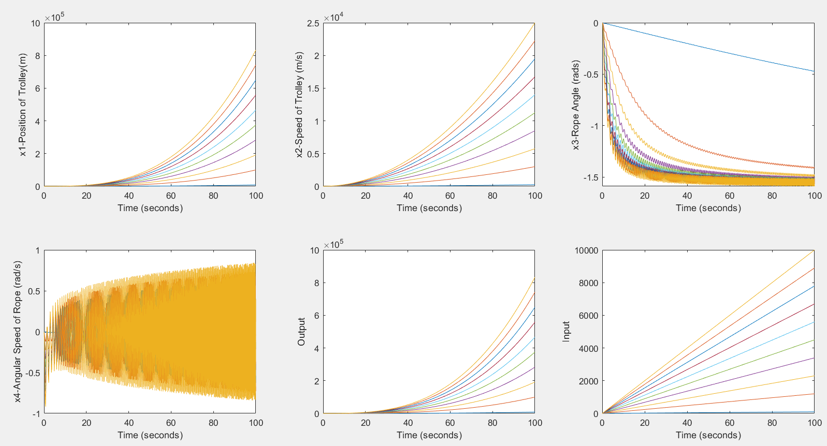

Trends: For a given value of ramp input, the value of x1, x2 and output Y corresponding to it increases as we increase the magnitude of input step force. Further, in x3 we notice that the vertex of the hyperbola-like curves is decreasing with increasing force input. In x4, the graphs are oscillatory but diverge with time. The amplitudes of these curves increase with increase in input force.

## 8.4 Most preferable input :

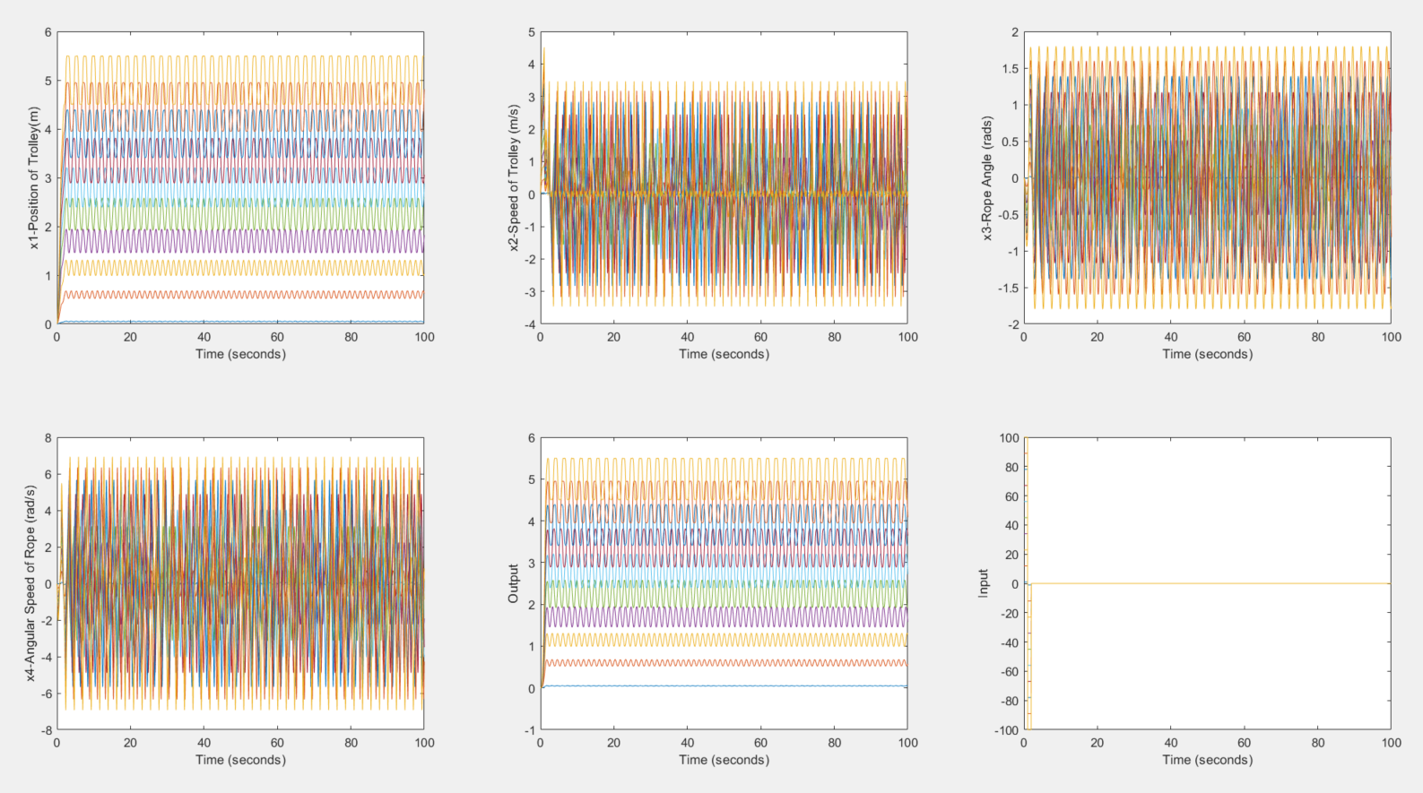

Trends: For the given value bang bang input, the initial value where the graphs start oscillating of x1 and output Y corresponding to it increases as we increase the magnitude of input step force. Further, the amplitude of oscillations of the speed of trolley (x2), angle subtended (x3) and also its angular speed (x4) increases gradually as we increase the input force on the system.

# 

# 

# 

# 

# 

# 

# 9. DISCUSSIONS ON VARYING STEADY STATE POINTS

Since our equilibrium points were of the form x = [x1 0 n*π 0], we analysed for even multiples of π above and analysis for odd multiples is done below.

## 9.1 Step Input

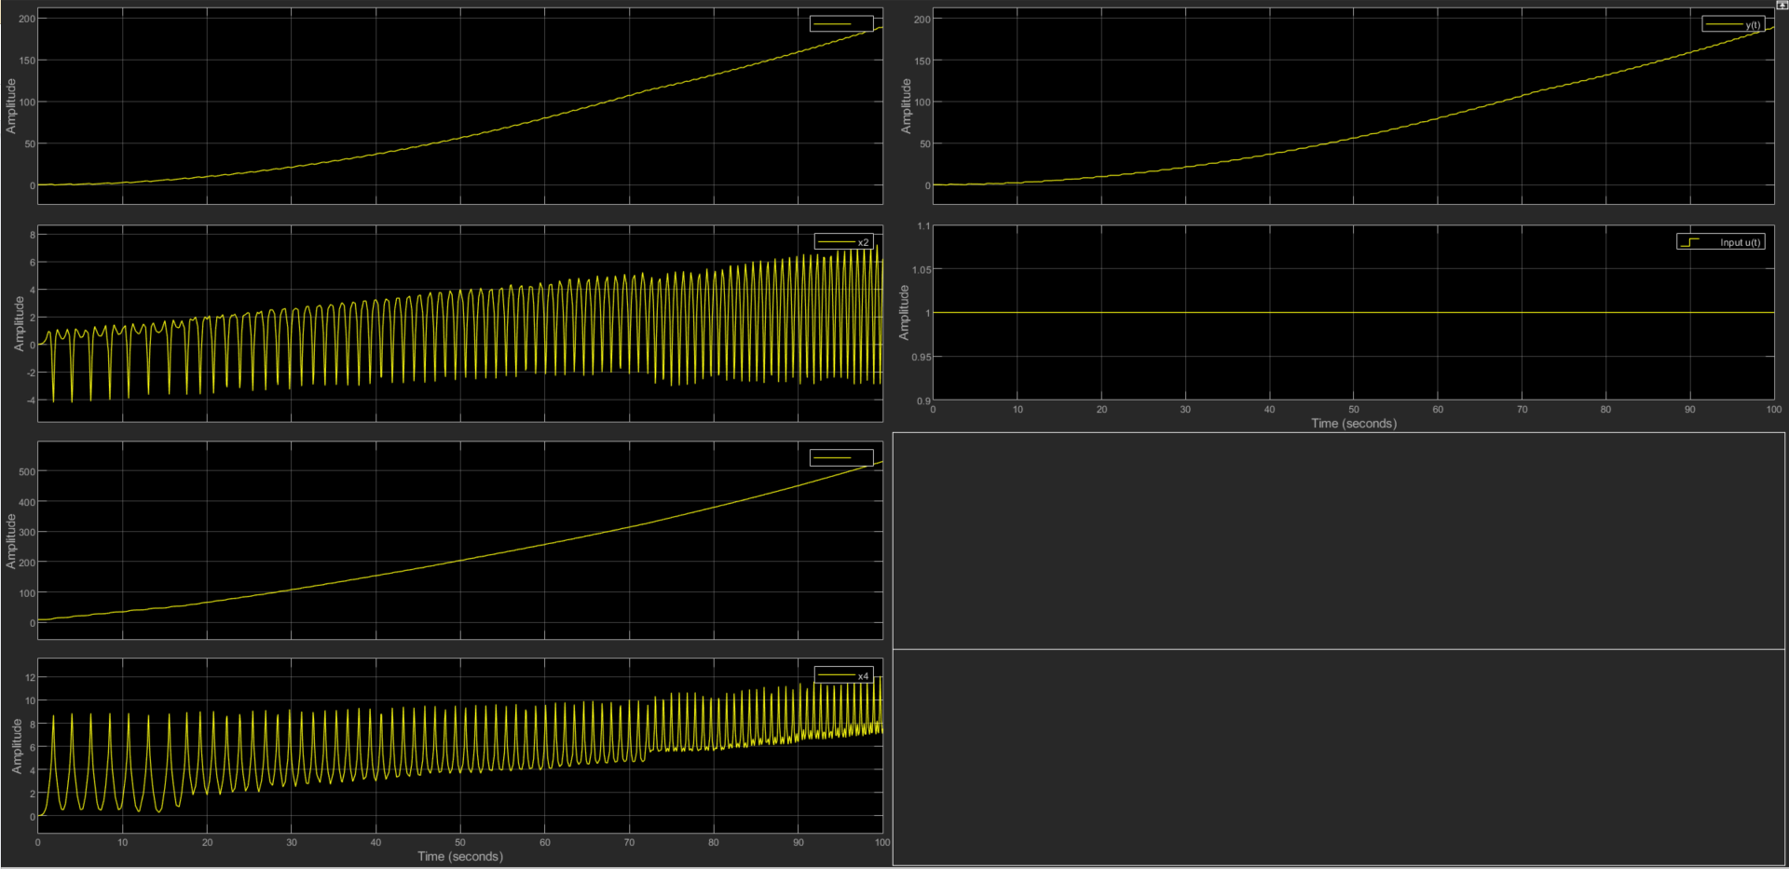

## 9.2 Impulse Input

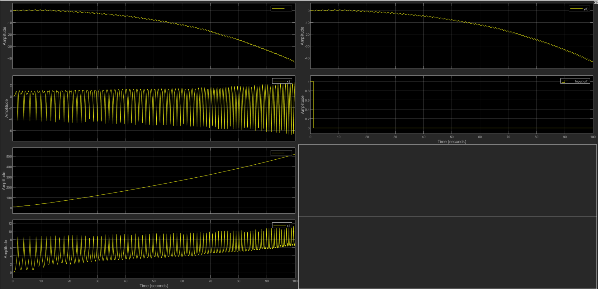

## 9.3 Ramp Input

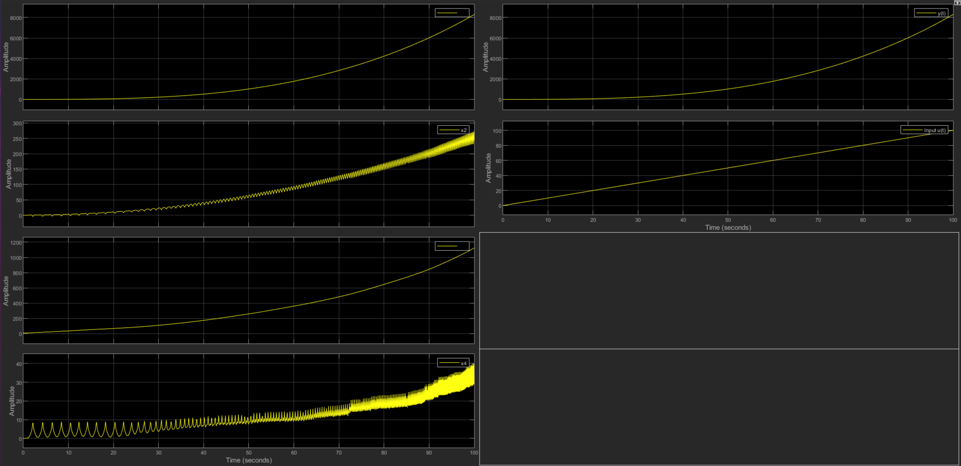

## 9.4 Bang-Bang Input

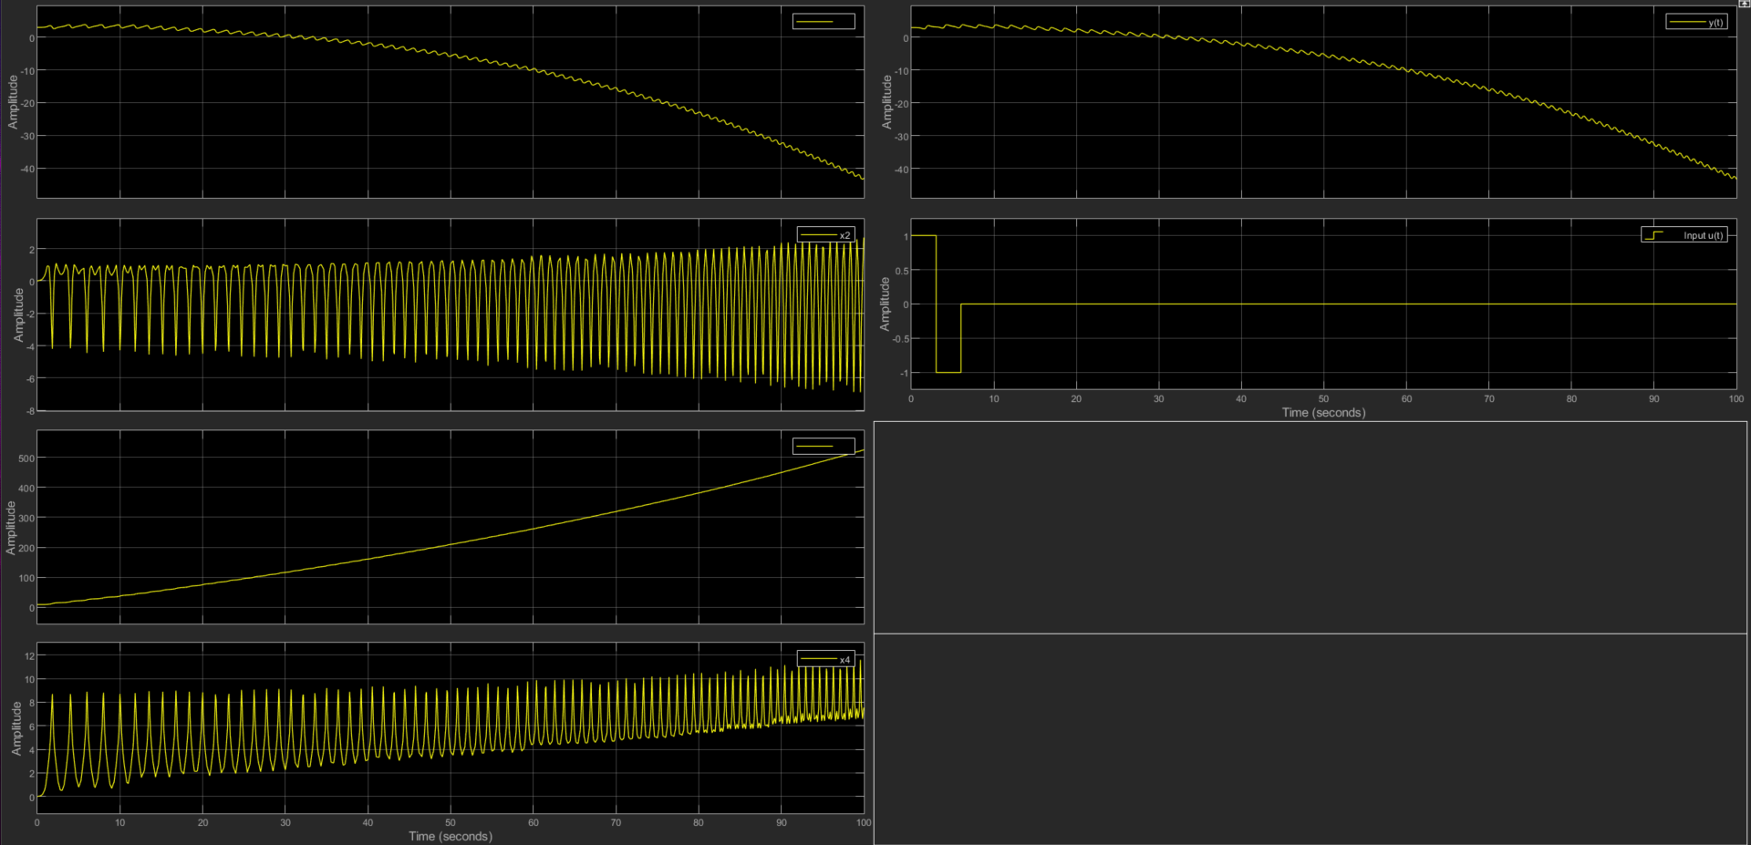

* Odd multiples of π (for state x3) was our point of unstable equilibrium. and as we can see x1 & x3 doesn’t achieve a specific value or oscillate about it. This confirms that it is indeed a point of instability.
* For states x2 & x4, we can see that they are showing increasing and oscillatory behaviour for all the inputs.

# 10. CONCLUSION

## Study and Comparisons between all inputs

We have obtained results for various inputs and observed the following results for every parameter:

* x1 in step , impulse , ramp inputs increases rapidly with time
* x2 in the step input and ramp input increases with time whereas we observe oscillatory nature in impulse input
* x3 in both step and impulse is oscillatory whereas we observe a negative non-linear graph for ramp input.
* x4 is found to be oscillatory in nature for all inputs.

## We studied the movement of trolley from steady state values obtained from Exp #8.

We have chosen the bang bang input (step with a magnitude for a given period of time t=2, and then another step with same magnitude but opposite direction in order to reduce the velocity to zero again and stop our crane once it reaches its desired location) as our most appropriate input. A small step signal is applied to start the movement of the crane for a small period of time and then when the crane is just about to reach the designated position (desired value of x1), the same force in opposite direction is applied (for the same time interval) to bring it to rest.

# 

# 

# 

# 11. MATLAB SCRIPT

